Corpus-C files are named as:
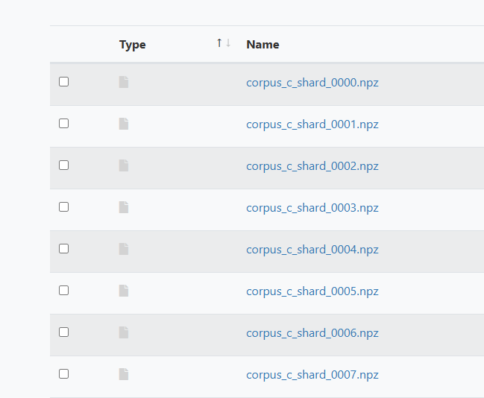

To get the statistics for the corpus and to inspect a particular sample in corpus C, follow these instructions:

module load anaconda loads the python environment
conda env list lists your specific environment that you’ll use
conda activate “your_env” you will get “your_env” from previous command
Now, we can run analyze_corpus_c.py and inspect_sample.py.
python3 analyze_corpus_c.py --corpus_dir corpusC --out corpus_c_stats.json stats
To inspect a sample:
python3 inspect_sample.py --shard corpusC/corpus_c_shard_0003.npz --dag 7 --out sample.json
To see how many DAGs are in a shard before picking one:
python3 inspect_sample.py --shard corpusC/corpus_c_shard_0003.npz

Once the above commands run, they will produce JSON files. Those JSON files can be dragged and dropped into the .html dashboard.

